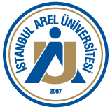 | REGISTRAR'S OFFICE  DISCIPLINARY CERTIFICATE APPLICATION FORM | Document No: FR.OIO.022  Release Date: 20.07.2023  Revision No: 00  Revision Date:

TO THE REGISTRAR'S OFFICE
I request a document to be prepared regarding whether I have been disciplined or not during my education at Istanbul Arel University.
Kindly submitted for necessary action.

(Student name, surname, signature)

Name and surname
Student number
T.R. Identity Number
Registered faculty/directorate
Registered department/program
Registration Date
Date of Graduation
Cell phone
E-mail

